**HR Analytics Dashboard Documentation**

**Project Title:**

**HR Analytics Dashboard Using Power BI**

**About the Project:**

This HR Analytics Dashboard is designed to provide comprehensive insights into employee attrition patterns within an organization. By leveraging Power BI for data visualization, it enables HR managers and decision-makers to analyse key factors influencing employee turnover, including demographic trends, job satisfaction, and business travel patterns. The dashboard uses an HR dataset containing attributes such as employee demographics, job roles, marital status, years of service, and education levels.

The primary goal is to offer actionable insights to optimize workforce management and reduce attrition.

**Technologies Used:**

1. **Excel:** Used for initial data cleaning and preparation.
2. **Power BI:** Used to create interactive visualizations and dashboards.

**Steps Overview:**

1. **Data Collection:** The dataset includes multiple employee-related attributes, such as age, gender, education, monthly income, job satisfaction, and attrition rates.
2. **Data Understanding:** The data was analysed to identify key metrics for visual representation.
3. **Data Transformation:** Columns like age were transformed into grouped categories for easier analysis.
4. **Data Visualization:** Power BI was used to create an interactive dashboard that includes charts, graphs, and key performance indicators (KPIs).

**Dashboard Overview:**

The dashboard is divided into two primary pages, each focusing on different aspects of employee data.

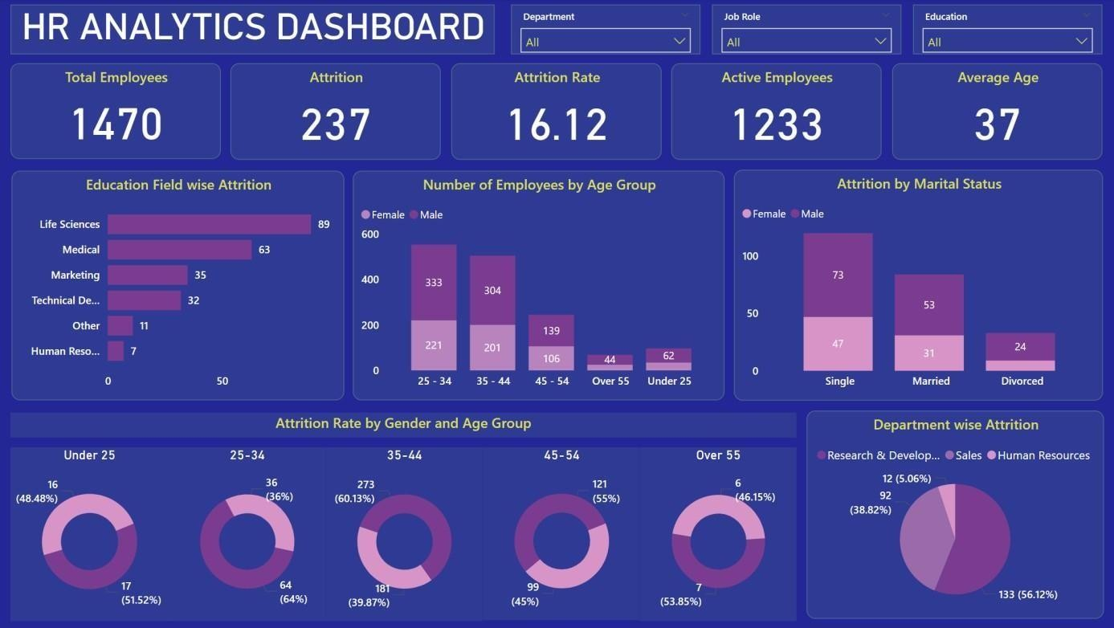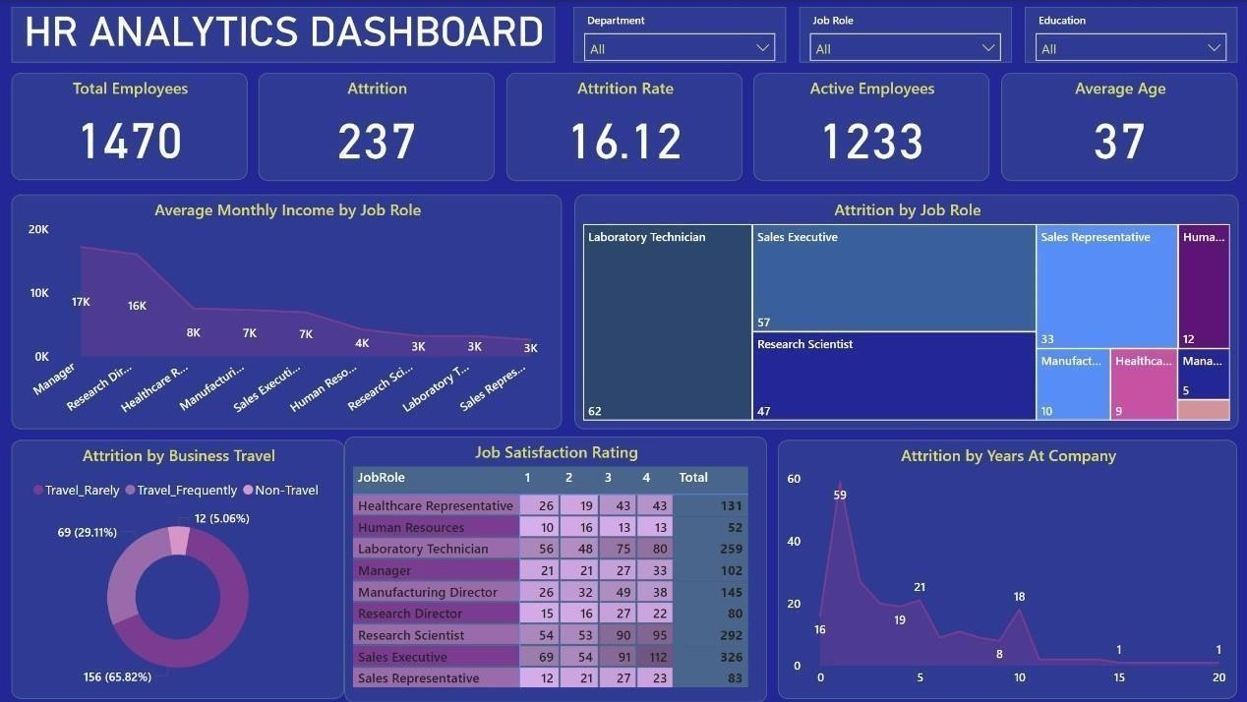

**Page 1 - General Overview and Demographics:**

**Key Performance Indicators (KPIs):**

1. **Total Employees:** Displays the total workforce count, i.e., 1,470 employees.
2. **Active Employees:** Represents the current number of employees (1,233).
3. **Attrition Count:** The total number of employees who left the organization is 237.
4. **Attrition Rate:** Indicates the percentage of attrition, which is 16.12%.
5. **Average Age:** Shows the average age of employees, calculated as 37 years.

**Visualizations and Insights:**

1. **Education Field Wise Attrition:**
   * A horizontal bar chart highlights attrition across education fields.
   * Life Sciences has the highest attrition count (89 employees), followed by Medical (63 employees).
   * Human Resources had the lowest attrition count (7 employees), making it 1,171.43% lower than Life Sciences.
2. **Number of Employees by Age Group:**
   * A stacked bar chart categorizes employees into age groups (e.g., 25-34, 35-44).
   * The 25-34 age group constitutes the majority, with males forming 333 and females 221 employees in this range.
3. **Attrition by Marital Status:**
   * This chart demonstrates that single employees have the highest attrition (73 males, 47 females).
4. **Department-Wise Attrition:**
   * A pie chart shows attrition by department. Research & Development has the highest attrition rate (56.12% of total attrition).
   * Human Resources exhibits significantly lower attrition in comparison.
5. **Attrition Rate by Gender and Age Group:**
   * Donut charts provide a granular view of attrition.
   * The attrition rate is highest for employees under 25, with females showing a slightly higher proportion than males.

**Page 2 - Job Roles, Business Travel, and Job Satisfaction:**

**Visualizations and Insights:**

1. **Average Monthly Income by Job Role:**
   * A stacked area chart compares income levels across job roles.
   * Managers have the highest average monthly income (₹17,181), which is 554.29% higher than Sales Representatives, who earn the least (₹2,626).
2. **Attrition by Job Role:**
   * A tree map visualizes attrition across job roles.
   * Laboratory Technicians (62 employees) and Sales Executives (57 employees) have the highest attrition, while Managers (5 employees) have the lowest.
3. **Attrition by Business Travel:**
   * A donut chart categorizes employees based on their travel frequency.
   * Employees who "Travel Rarely" account for the majority of attrition (65.82%), while "Non-Travel" employees have the least attrition (5.06%).
4. **Job Satisfaction Rating:**
   * A matrix chart displays satisfaction levels across different roles.
   * Sales Executives, despite having varied satisfaction ratings, exhibit the highest attrition (112 employees).
5. **Attrition by Years at Company:**
   * An area chart shows trends in attrition over time.
   * Attrition peaks during the first year (59 employees leave), indicating challenges in early retention.
   * After the first year, attrition drops significantly, with a gradual decline over time.

**Key Insights:**

1. **Demographics and Attrition:**
   * Younger employees (<25 years) have a significantly higher attrition rate, especially females.
   * Single employees are more likely to leave the organization compared to married or divorced employees.
2. **Departmental Trends:**
   * Research & Development faces the greatest attrition challenges, necessitating targeted retention strategies.
   * Departments with lower attrition, such as Human Resources, may serve as benchmarks for improvement.
3. **Job Role and Income:**
   * Lower-paid roles, such as Sales Representatives and Laboratory Technicians, exhibit higher attrition rates.
   * Higher-earning roles, such as Managers, tend to retain employees longer.
4. **Job Satisfaction and Business Travel:**
   * Employees with lower job satisfaction are more likely to leave, especially in customer-facing or travel-intensive roles.
   * Frequent travel is linked to moderate attrition rates, indicating a need for better work-life balance.
5. **Retention Challenges in Early Tenure:**
   * High attrition within the first year highlights onboarding or integration issues.
   * Improved support for new hires may reduce early turnover.

**Summary of Findings**

* Out of the total 1470 employees, there was an attrition rate of 16.12%, equating to 237 employees who left the company.
* The Research & Development department has the highest attrition rate for 56.12% (133 employees) of the total number of employees.
* Life Sciences recorded the most attritions among educational fields, with 89 employees.
* The most significant attrition occurred among male employees aged between 25 to 34 years.
* Employees who rarely traveled experienced the most substantial attrition, amounting to 65.82% (156 people) of the total employees.
* Single male employees experienced the highest number of attritions.
* Employees with shorter tenures at the company displayed a higher attrition rate compared to those with longer tenures.
* The Laboratory Technician job role has the highest number of employee attrition compared to other roles.

**Suggestions**

* Conduct surveys or interviews to understand the specific issues leading to attrition within the Research & Development department. For instance, identify if it's related to workload, leadership, growth opportunities, or other factors causing dissatisfaction.
* Develop strategies specifically for Laboratory Technicians such as career development paths, skills training, or mentorship programs tailored to address the unique needs and career aspirations of Laboratory Technicians.
* For reduced attrition among employees aged 25-34 or singles, company could provide options like flexible work, career development programs, and initiatives promoting work-life balance.
* The company could provide comprehensive onboarding, mentorship, and regular feedback mechanisms for new employees to acclimate well and feel valued within the company, reducing early attrition.

**Conclusion:**

This HR Analytics Dashboard serves as a critical tool for HR managers, enabling them to:

* Identify patterns of employee attrition by department, role, and demographics.
* Understand the impact of factors like job satisfaction, income, and business travel on retention.
* Develop data-driven strategies to improve employee engagement, retention, and workforce management.

By leveraging the insights provided, HR teams can address key challenges, optimize employee satisfaction, and strengthen organizational performance.